Our Lady’s Catholic Primary School
Information Pack for Parents – December 2021
Section 1 – Basic Information
- What is SEND?
https://www.knowsleyinfo.co.uk/content/what-send-and-changes-introduced-send-reforms
- Who is the SENCO, and how can they be contacted?
Mrs McCoy is the school SENCO, and can be contacted via the school office on 0151 477 8220.
- If you have any concerns with your child what should you do first?

Firstly, contact your child’s class teacher to discuss any concerns you have.

- How does the school deal with SEND on a daily basis?

Please click below to view the school SEND offer and information related to what is on offer in school to support children with SEND.

School-Local-Offer-SEND-Information-Report-November-2021.docx (live.com)

- What is the local offer/where do I find it?

https://www.knowsleyinfo.co.uk/
https://www.knowsleyinfo.co.uk/content/what-local-offer

- How do you complain if you are dissatisfied with what is being offered?
See the complaints procedure on our school website.
Complaints-Policy-and-Procedure-3-1.pdf (ourladysprescot.com)

Section 2 – Parental Support
The following organisations provide support for parents of children with SEND
- Liverpool & Knowsley SEND IASS (Special Educational Needs and/or Disabilities, Information, Advice & Support Service)

Tel: 0800 012 9066 Option 2 for Knowsley

email: liverpoolandknowsleysend@wired.me.uk
Stoneycroft Children’s Centre
38 Scotia Road
Liverpool
L13 6QJ
Liverpool & Knowsley SEND IASS (Special Educational Needs and/or Disabilities, Information, Advice & Support Service) | Knowsley Family Information Service (knowsleyinfo.co.uk)
- Knowsley Parent Carer Voice

Tel: 07376 233141

Email: Infokpcv@gmail.com
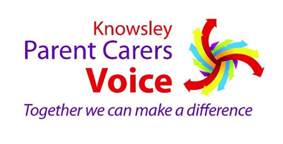
Knowsley Parent Carers Voice
C/o Knowsley CCG
Ebony Way
Liverpool
L33 1XT

Knowsley Parent Carers Voice (KPCV) | Knowsley Family Information Service (knowsleyinfo.co.uk)

- ADDvanced Solutions

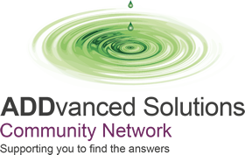
ADDvanced Solutions Community Network aims to improve the emotional health and wellbeing of families living with neurodevelopmental conditions, learning difficulties and associated mental health needs through a social model of learning and support; engaging, educating, encouraging, equipping and empowering families to better recognise, understand and meet their own needs and those of the their family, building resilience to help them manage everyday challenges whilst increasing participation and reducing social isolation.
https://www.addvancedsolutions.co.uk/home.html

- Isabella Trust
The Isabella Trust is a registered charity which aims to provide information, support, training, courses and workshops to parents and carers of autistic children and children who experience sensory processing difficulties.
Tel: 07956 749774
Email: info@theisabellatrust.org
http://www.theisabellatrust.org/

- ADHD Foundation
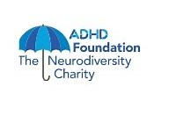
The ADHD Foundation Neurodiversity Charity is an integrated health and education service offering a unique lifespan – strength-based service, for the 1 in 5 people who live with ADHD, Autism, Dyslexia, Dyspraxia, Dyscalculia and Tourette’s syndrome.
https://www.adhdfoundation.org.uk/

- Sensory Hive
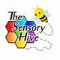
Email: thesensoryhive@gmail.com

https://www.facebook.com/thesensoryhive/

- Contact
Support families with the best possible guidance and information. Bring families together in local groups and online, to support each other by sharing experiences and advice. And we help families to campaign, volunteer, fundraise and shape local services to improve life for themselves and others.
https://www.contact.org.uk/

- IPSEA
IPSEA offers free and independent legally based information, advice and support to help get the right education for children and young people with all kinds of special educational needs and disabilities (SEND). We also provide training on the SEND legal framework to parents and carers, professionals and other organisations.

Tel: 01799 582030
https://www.ipsea.org.uk/

Section 3 – Support Plans for your Child
- What is an IEP?
When a child is placed on the SEN register, they will have a support plan put in place by the school. This may be called an IEP (Individual Education Plan), PPP (Personal Provision Plan) or another name like a Pupil Passport.
What is an IEP? | The Good Schools Guide

- What is an EHCP (Education, Health and Care Plan)?
https://www.knowsleyinfo.co.uk/content/general-information-about-sen-schools-and-ehcp-process

- What is Early Help?
https://www.knowsleyinfo.co.uk/content/what-early-help

Section 4 - Further specific support
- What is the Pathway?
The ND or Neuro-developmental Pathway in Knowsley is run by a company called Clinical Partners. Children and young people are assessed to see if they have autism (ASC) or attention deficit hyperactivity disorder (ADHD).
Clinical Partners will soon send out information for parents regarding the assessment process and contact details.

- Which professional might see my child?

Educational Psychologists https://www.knowsleyinfo.co.uk/content/educational-psychology-service-about-us

Children’s Therapy Service including Speech and Language Therapists, Occupational Therapists and Physiotherapists
https://www.knowsleyinfo.co.uk/content/childrens-therapy-service-%E2%80%93-speech-and-language-therapy-occupational-therapy-and

CAMHS (Child and Adolescent Mental Health Service) CAMHS Team Knowsley | Knowsley Family Information Service

- How do I find out if my child can have transport to school?
SEN Home to School Transport | Knowsley Family Information Service (knowsleyinfo.co.uk)

