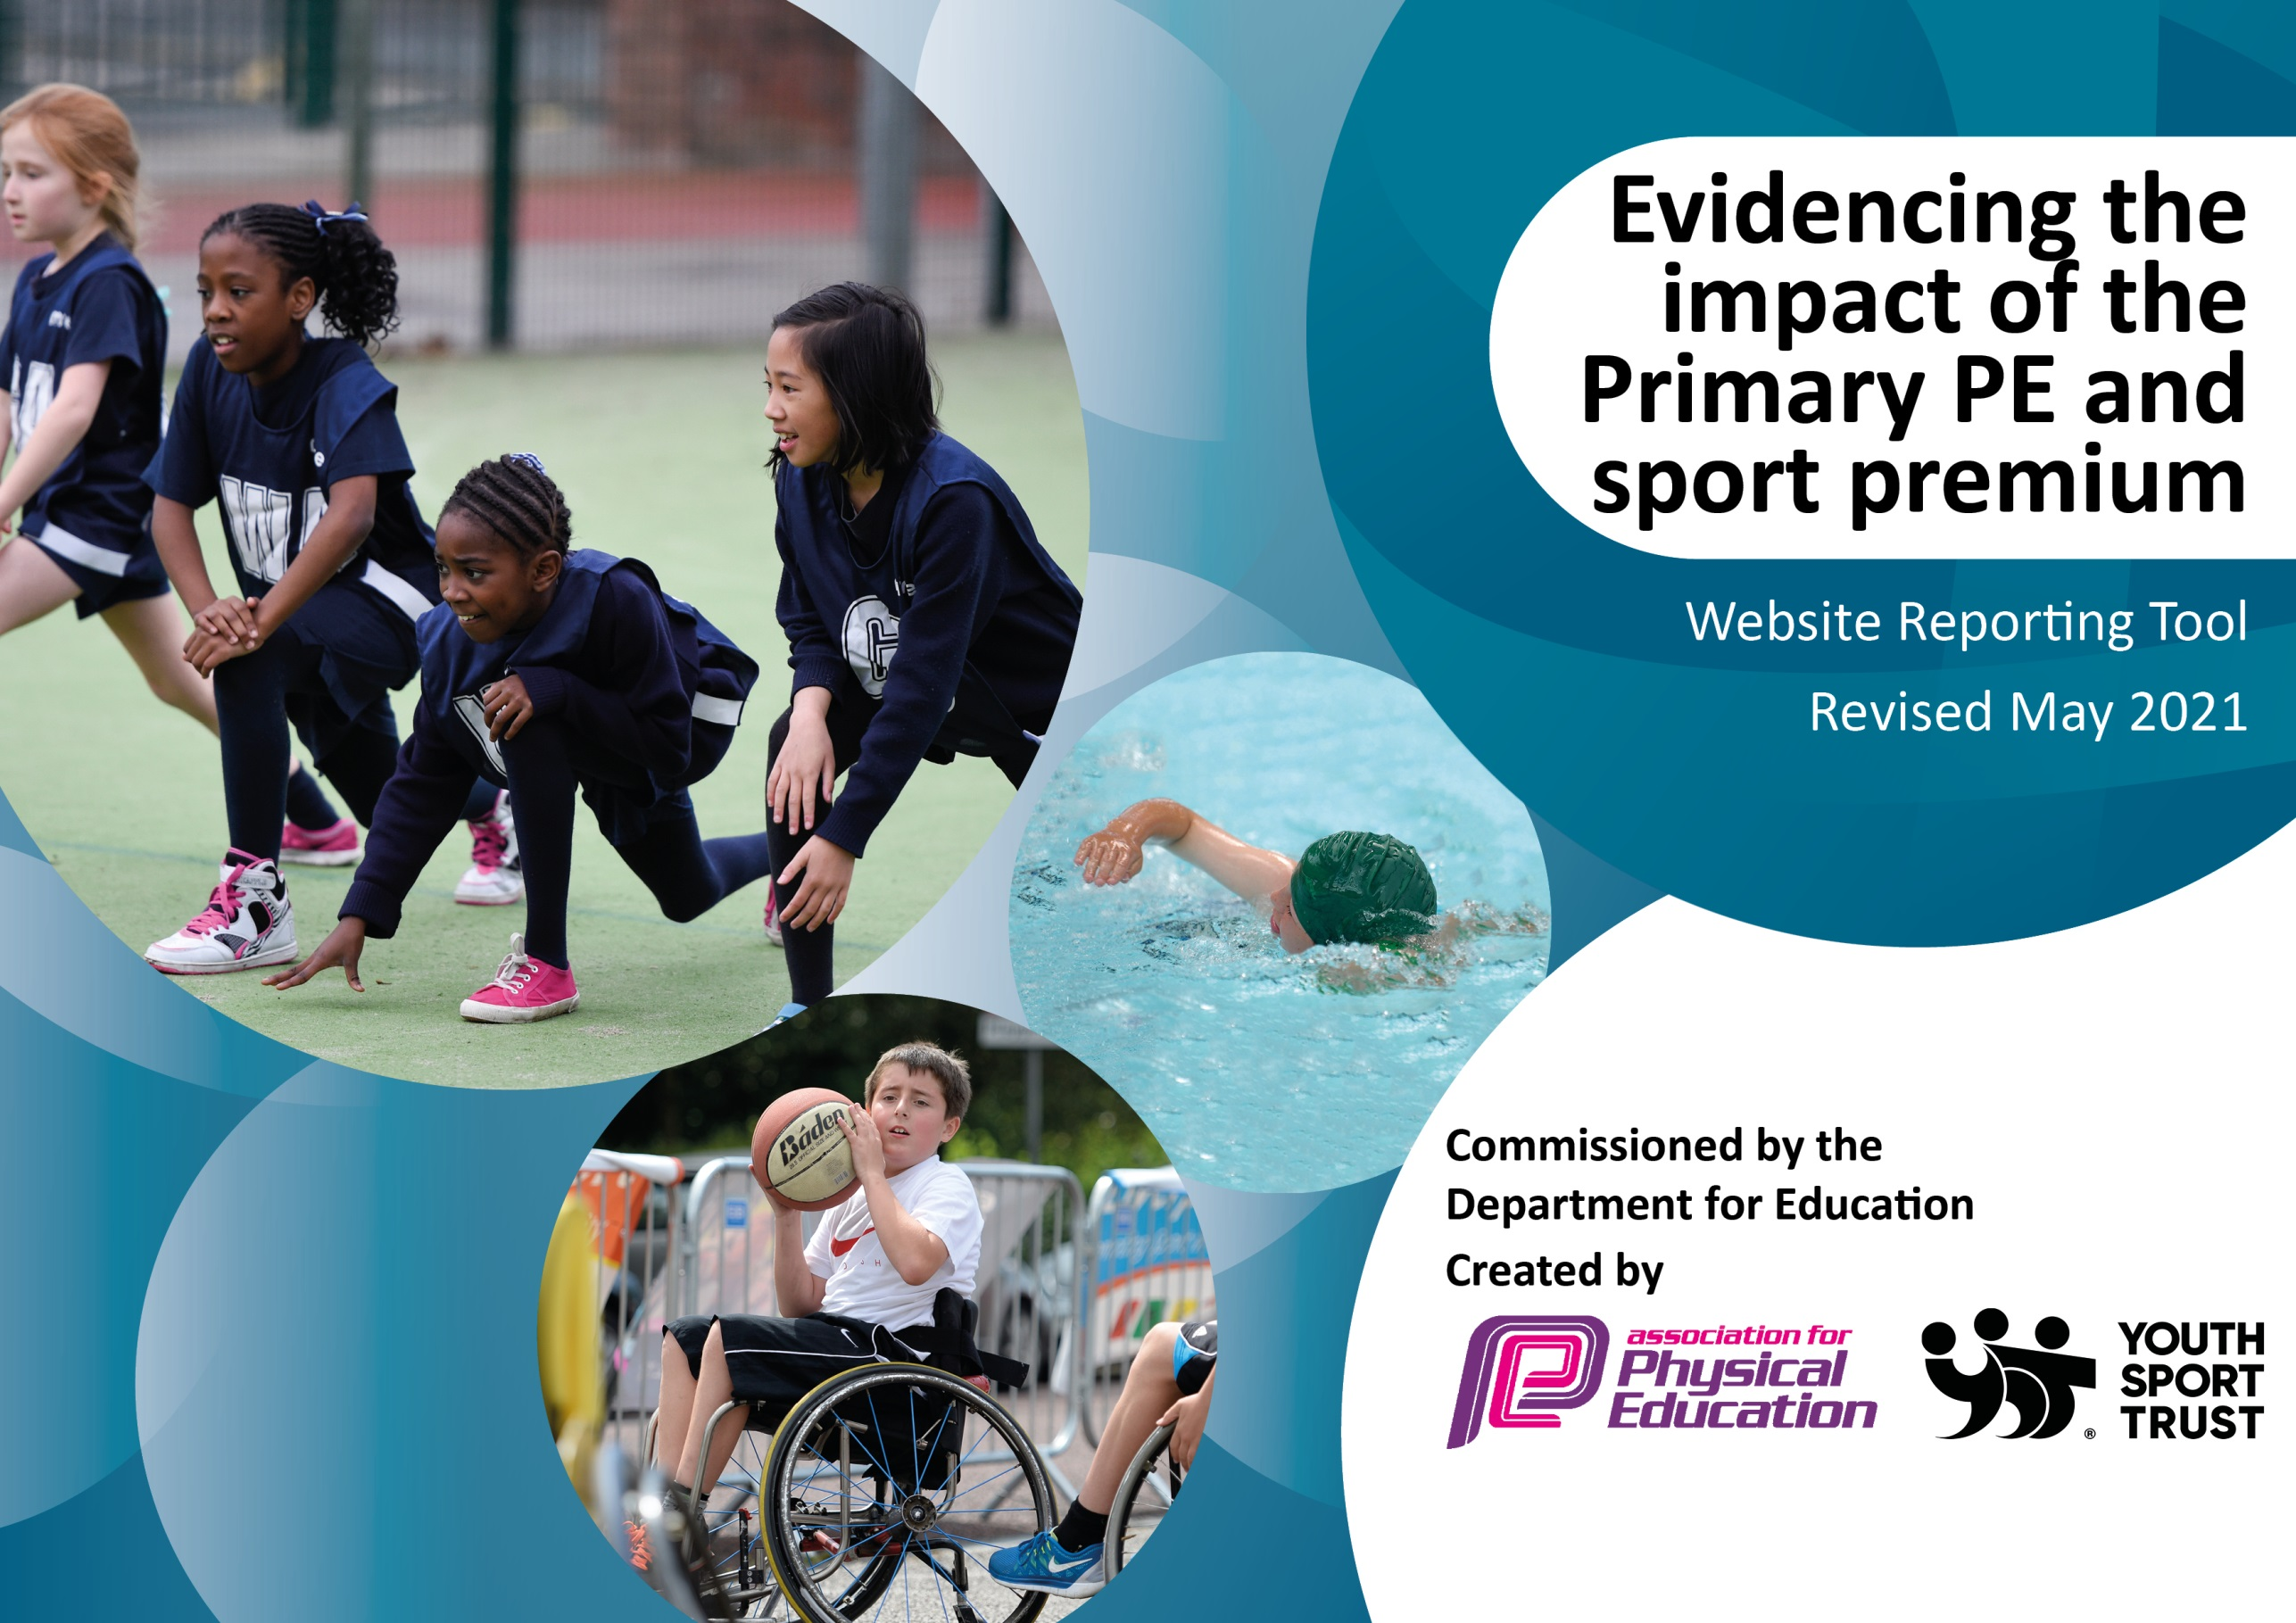

It is important that your grant is used effectively and based on school need. The Education Inspection Framework (Ofsted 2019 p64) makes clear there will be a focus on ‘whether leaders and those responsible for governors all understand their respective roles and perform these in a way that enhances the effectiveness of the school’.

Under the Quality of Education criteria (p41) inspectors consider the extent to which schools can articulate their curriculum (INTENT), construct their curriculum (IMPLEMENTATION) and demonstrate the outcomes which result (IMPACT).

To assist schools with common transferable language this template has been developed to utilise the same three headings which should make your plans easily transferable between working documents.

Schools must use the funding to make additional and sustainable improvements to the quality of Physical Education, School Sport and Physical Activity (PESSPA) they offer. This means that you should use the Primary PE and sport premium to:

- Develop or add to the PESSPA activities that your school already offer
- Build capacity and capability within the school to ensure that improvements made now will benefit pupils joining the school in future years
- The Primary PE and sport premium should not be used to fund capital spend projects; the school’s budget should fund these.
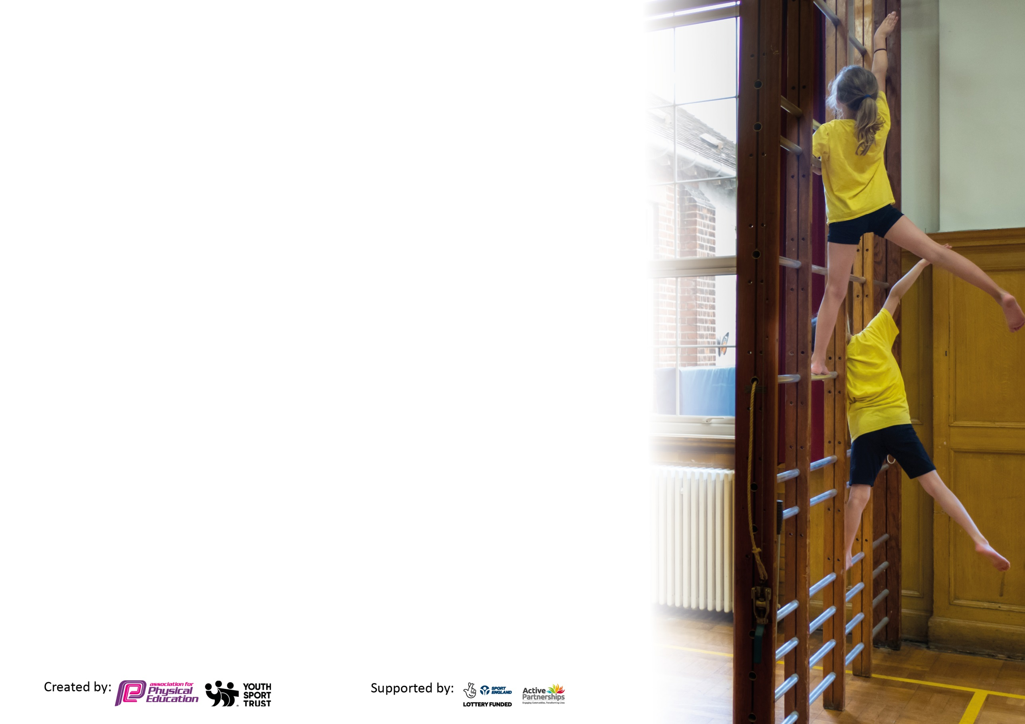
Please visit gov.uk for the revised DfE guidance including the 5 key indicators across which schools should demonstrate an improvement. This document will help you to review your provision and to report your spend. DfE encourages schools to use this template as an effective way of meeting the reporting requirements of the Primary PE and sport premium.

We recommend you start by reflecting on the impact of current provision and reviewing the previous spend.

Schools are required to publish details of how they spend this funding, including any under-spend from 2019/2020, as well as on the impact it has on pupils’ PE and sport participation and attainment by the end of the summer term or by 31st July 2021 at the latest.

We recommend regularly updating the table and publishing it on your website throughout the year. This evidences your ongoing self-evaluation of how you are using the funding to secure maximum, sustainable impact. Final copy must be posted on your website by the end of the academic year and no later than the 31st July 2021. To see an example of how to complete the table please click HERE.

Please note: Although there has been considerable disruption in 2020 it is important that you publish details on your website of how you spend the funding - this is a legal requirement.
Support for review and reflection - considering the 5 key indicators from DfE, what development needs are a priority for your setting and your pupils now and why? Use the space below to reflect on previous spend and key achievements and areas for development.

N.B. In this section you should refer to any adjustments you might have made due to Covid-19 and how these will influence further improvement.
Key achievements to date until July 2020: | Areas for further improvement and baseline evidence of need:

Did you carry forward an underspend from 2019-20 academic year into the current academic year?

NO

Meeting national curriculum requirements for swimming and water safety.

N.B Complete this section to your best ability. For example you might have practised safe self-rescue techniques on dry land which you can transfer to the pool when school swimming restarts.
Due to exceptional circumstances priority should be given to ensuring that pupils can perform safe self rescue even
if they do not fully meet the first two requirements of the NC programme of study.
What percentage of your current Year 6 cohort swim competently, confidently and proficiently over a distance of at least 25 metres?  N.B. Even though your pupils may swim in another year please report on their attainment on leaving primary school at the end of the summer term 2021.  Please see note above. | 60%
What percentage of your current Year 6 cohort use a range of strokes effectively [for example, front crawl, backstroke and breaststroke]?  Please see note above. | 60%
What percentage of your current Year 6 cohort perform safe self-rescue in different water-based situations? | 100%
Schools can choose to use the Primary PE and sport premium to provide additional provision for swimming but this must be for activity over and above the national curriculum requirements. Have you used it in this way? | No

Action Plan and Budget Tracking
Capture your intended annual spend against the 5 key indicators. Clarify the success criteria and evidence of impact that you intend to measure to evaluate for pupils today and for the future.

Academic Year: 2020/21 | Total fund allocated: £ | Date Updated:
Key indicator 1: The engagement of all pupils in regular physical activity – Chief Medical Officers guidelines recommend that primary school pupils undertake at least 30 minutes of physical activity a day in school |  |  |  | Percentage of total allocation:
 |  |  |  | %
Intent | Implementation |  | Impact
Your school focus should be clear what you want the pupils to know and be able to do and about  what they need to learn and to  consolidate through practice: | Make sure your actions to achieve are linked to your intentions: | Funding allocated: | Evidence of impact: what do pupils now know and what can they now do? What has changed?: | Sustainability and suggested next steps:
- Continue to schedule ‘The Daily Mile’ in to everyday school timetable.  - All children in EYFS to complete daily physical activities.  - Offer more extra curricular opportunities.  - All key stage 2 children to take part in 8 swimming sessions over intensive 2 week block.  Continue to offer Sensory Circuit every morning to specific cohort of children | - Monitor and oversee to ensure completion as and when possible.  - Maybe involve midday supervisors to promote completion during lunchtime.  - Encourage children to keep a log of their performance and to strive to improve their time to complete or distance covered in set time.  - Coordinate with EYFS staff that a range of physical activity opportunities are offered on a daily basis: -  - Cosmic Yoga  - BBC Super Movers  - Yoga  - Music and Dance  - Daily active play  - Go Noodle  - Active Dance Moves  - Ensure more regular after school clubs are offered throughout the year.  - Offer a range of different sports/activities.  - Rotate opportunities to ensure provision for all children.  - Provide opportunities for all children in key stage 2.  - Orgainse sessions with local leisure centre and instructors.  - Organise additional qualified staff to attend and coach.  - Ensure 100 % of children can swim 25 meters at the end of year 6 in line with national curriculum for physical education.  - Develop children’s competence to complete the recommended 25m in a range of strokes.  - Liaise with SENCO to select children from all year groups to attend who will benefit from provision.  - Coordinate with SENCO to ensure meaningful activities are offered.
Key indicator 2: The profile of PESSPA being raised across the school as a tool for whole school improvement |  |  |  | Percentage of total allocation:
 |  |  |  | %
Intent | Implementation |  | Impact
Your school focus should be clear what you want the pupils to know and be able to do and about  what they need to learn and to  consolidate through practice: | Make sure your actions to achieve are linked to your intentions: | Funding allocated: | Evidence of impact: what do pupils now know and what can they now do? What has changed?: | Sustainability and suggested next steps:
- Organise Junior Play Leader Training for current year 5 children. (20 children)  - Use leadership to promote confidence, organisation and communication skills.  - Celebrate participation and success when possible of sports teams in stars assembly on Friday mornings. Promote the importance of PE and school sport and encourage all children to aspire to being involved.  Maintain Sainsburys School Games Award. (On hold till 2022) | - Establish date with D. Sweeney to complete training for selection of year 5 children.  - Promote regular leadership opportunities for year 5 children in all PE lessons to maintain confidence.  - Organise timetable for children to offer games and activities every day.  - Coordinate basic equipment for leaders to use when providing playground opportunities.  - Provide simple activity resources for leaders to use to ensure quality opportunities are offered.  - Provide opportunities for all children to lead warm ups and small activities in PE time.  - Plan for leadership opportunities in all PE lessons. Ensure all children get the chance to lead their peers.  - Participation and achievements shared and celebrated – match results and exceptional performances in PE lessons (star of the day award).  - Develop and update PE Notice board informing children of fixtures and sharing team photos and match reports.  - Continue to work towards specific criteria ensuring opportunity for all.

Key indicator 3: Increased confidence, knowledge and skills of all staff in teaching PE and sport |  |  |  | Percentage of total allocation:
 |  |  |  | %
Intent | Implementation |  | Impact
Your school focus should be clear | Make sure your actions to | Funding | Evidence of impact: what do | Sustainability and suggested
what you want the pupils to know | achieve are linked to your | allocated: | pupils now know and what | next steps:
and be able to do and about | intentions: |  | can they now do? What has
what they need to learn and to |  |  | changed?:
consolidate through practice:
- Continue to monitor teaching of PE across whole school.  - Ensure all children receive 2 hours of Physical Education every week. | - All staff will be supported to feel confident to deliver PE and Sport both within and outside the curriculum.  - Team teach PE when possible.  - Share PE resources.  - Share plans, records and assessment information to ensure continuity and progression for all children.  - Share CPD opportunities with all staff offered through Knowsley School Sport Partnership.  Demonstrate and promote high quality lessons that include the following:  - Structured lessons and units of work that demonstrate progression and continuity.  - Range of activities and or sports offered.  - Differentiated learning activities.  - Identification of mastery learners and suitable activities that promote progression.  - Inclusion for SEN or low ability.  - Peer and self assessment opportunities.  - Leadership opportunities in every lesson.  - Competitive opportunities suitable for ability.  - Cross curricular links when and where possible (e.g. science and maths)  - Establish whole school PE timetable allocating 2 hours of PE for all children.
Key indicator 4: Broader experience of a range of sports and activities offered to all pupils |  |  |  | Percentage of total allocation:
 |  |  |  | %
Intent | Implementation |  | Impact
Your school focus should be clear | Make sure your actions to | Funding | Evidence of impact: what do | Sustainability and suggested
what you want the pupils to know | achieve are linked to your | allocated: | pupils now know and what | next steps:
and be able to do and about | intentions: |  | can they now do? What has
what they need to learn and to |  |  | changed?:
consolidate through practice:
Additional achievements:  - Continue to offer a PE curriculum that is broad, balanced and flexible.  - Use specialist coaches to deliver sessions in specific sports.  - Develop Tag Rugby in PE at Key Stage 2.  Provide opportunities for SEN and sensory needs children on a daily basis. | - Use a variety of equipment in PE lessons for key stage 1 and EYFS.  - Attend sessions offered by KSSP.  - Introduce competition in PE for key stage 1 and develop teams to compete out of school.  - Offer a variety of different sports within PE for key stage 2.  - Introduce new sports in PE time. (e.g. handball)  - Orgainse coaches to deliver specialist sessions in PE time.  - Offer Tag Rugby in PE time to promote sport.  - Develop teams to represent school and compete in competitions.  Target specific children across the whole school to participate in a sensory circuit every morning.

Key indicator 5: Increased participation in competitive sport |  |  |  | Percentage of total allocation:
 |  |  |  | %
Intent | Implementation |  | Impact
Your school focus should be clear | Make sure your actions to | Funding | Evidence of impact: what do | Sustainability and suggested
what you want the pupils to know | achieve are linked to your | allocated: | pupils now know and what | next steps:
and be able to do and about | intentions: |  | can they now do? What has
what they need to learn and to |  |  | changed?:
consolidate through practice:
- Enter more competitions in a greater variety of sports.  - Provide competitive opportunities for lower ability children.  - Offer more competitive opportunities for SEND children.  - Provide competitive opportunities in PE lessons.  - Develop inter-house competition at key stage 2. | - Pay Partnership annual fees.  - Use Knowsley School Sport Partnership (KSSP) calendar to attend as many events as possible.  - Coordinate more staff to take children to competitions.  - Establish links with neighboring school(s) and arrange fixtures for ‘B’ teams.  - Continue to offer extra curricular opportunities in cross country to all children in Key Stage 2.  - All children given the opportunity to represent the school and compete in cross country events.  - Attend specific competitions organized by KSSP for SEND children.  - Ensure children are grouped by ability during friendly competition in PE lessons.  - Work with class teachers to organise opportunities.  - Group classes together to provide meaningful competition and opportunity for children to work with younger/older children (year 3 and 4 - year 5 and 6).

Signed off by
Head Teacher:
Date:
Subject Leader:
Date:
Governor:
Date:

