Our Lady’s Catholic Primary School

April 2021

Online Safety Newsletter

Choosing apps

We receive lots of queries about different apps, which when they are less known, we’re reluctant to name and raise awareness of so instead we thought we’d provide you with some pointers to help you decide if an app is appropriate or not for your child.

- Starting point would be to look at the age rating – is your child old enough to be playing it? Also please be aware that apps are often rated by the developer themselves. https://www.net-aware.org.uk/news%2Fage-content-ratings-apps-games/
- Regardless of the age rating, does the app include any communication options such as chat or commenting? If yes, this can add greater risk and you will need to decide if the app is then appropriate. Try to use the app first so you can check it.
- Use the app with your child, show them any blocking/reporting tools.
- Does the app have any parental controls?
- Read the app reviews – is there anything that concerns you?
- Google the app – is there anything in the news that concerns you?
- Play and use the app together
- Talk to your child regularly about what they are doing online.

TikTok: new tools

You must be over 13 years of age to use TikTok.

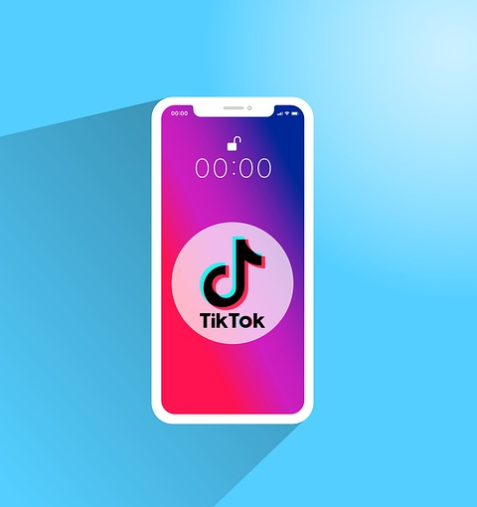
TikTok have introduced new tools to try and promote kindness on their platform. The new ‘Filter All Comments’ feature means that you can choose which comments will appear on your videos.
https://newsroom.tiktok.com/en-us/new-tools-to-promote-kindness

This article may be of interest too as it outlines three features which you should know about if your child is using TikTok:
https://newsroom.tiktok.com/en-us/three-tiktok-features-every-parent-should-know

Reminder: Blocking and Reporting
Don’t forget to show your child how to report (https://support.tiktok.com/en/safety-hc/report-a-problem/report-a-user) and block other users (https://support.tiktok.com/en/using-tiktok/followers-and-following/blocking-the-users ).

TikTok have also produced several "You're in Control" videos to show users how to use TikTok more safely. These are available here: https://newsroom.tiktok.com/en-us/youre-in-control-video-series-stars-tiktok-creators-to-educate-users-about-safety-features

Further information
http://support.tiktok.com
Become an Online Hero!

Captain Safety is the LEGO® digital safety hero and he is on a mission. This quiz is designed for children to complete so they can become an online safety hero!

https://www.lego.com/en-gb/campaigns/kids/safer-internet-day

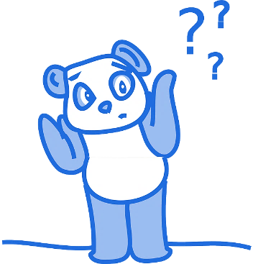

Users of this guide do so at their own discretion. No liability is entered into. Current as of the date released 1.4.21.

Hollie Guard App

The Hollie Guard app allows you to keep an eye on your child while they are traveling using the Journey feature, so whenever they use this feature, their emergency contacts are informed when they have arrived at their destination.

Users can also use this app to get help quickly if they’re in danger. If a user is in danger, they shake or tap their phone, which activates Hollie Guard and automatically sends their location to their designated contacts.
It can also activate a high-pitched alarm. Visit their website for further information: https://hollieguard.com/

Harmful online challenges/hoaxes
“A hoax is a deliberate lie designed to seem truthful. The internet and social media provide a perfect platform for hoaxes, especially hoaxes about challenges or trends that are said to be harmful to children and young people to be spread quickly. You should carefully consider if a challenge or scare story is a hoax. Generally speaking, naming an online hoax and providing direct warnings is not helpful. Concerns are often fuelled by unhelpful publicity, usually generated on social media, and may not be based on confirmed or factual occurrences or any real risk to children and young people.”
https://www.gov.uk/government/publications/harmful-online-challenges-and-online-hoaxes/harmful-online-challenges-and-online-hoaxes [Accessed 15.3.21].

Whilst we do not recommend talking to your child about specific challenges (it draws attention to them), we do recommend talking to your child about challenges that may appear on the internet. Make sure they know that they should talk to you about what they see online, particularly if it scares or upsets them as you can help them to block and report the content.
Disney parental controls

Does your child watch Disney+? If so, have you set up the parental controls to ensure that what your child is watching it, it is appropriate to them? More information is available here:

https://help.disneyplus.com/csp?id=csp_article_content&sys_kb_id=9582efcbdb1aac50055ceadc13961917

Reassure your child that challenges that suggest that bad stuff will happen if they don’t complete the tasks are not real.

The following links will provide you with further information as well as content to help you talk to your child:
Spotify Kids

Spotify Kids is available as part of a paid for Premium family subscription. With Spotify Kids, your child will have their own account to access child-friendly content (picked by Spotify).

You can also share playlists with them - remember that if this playlist includes songs marked explicit (marked with an E) then your child will be able to listen to them. Further information is available here:

https://support.spotify.com/us/article/spotify-kids/

- https://www.thinkuknow.co.uk/parents/articles/theres-a-viral-scare-online-what-should-i-do/

- https://www.saferinternet.org.uk/blog/online-challenges-and-peer-pressure
- https://www.bbc.com/ownit/its-personal/when-you-see-something-scary-online
- https://www.bbc.com/ownit/dont-panic/what-to-do-if-you-see-something-upsetting-online
- https://www.net-aware.org.uk/news/how-can-we-teach-kids-to-spot-fake-news-online/
Socialising safely online

Internet Matters have published this helpful article which includes some useful pointers as well as some fun activities for your child:

https://www.internetmatters.org/hub/news-blogs/socialising-safely-online/

