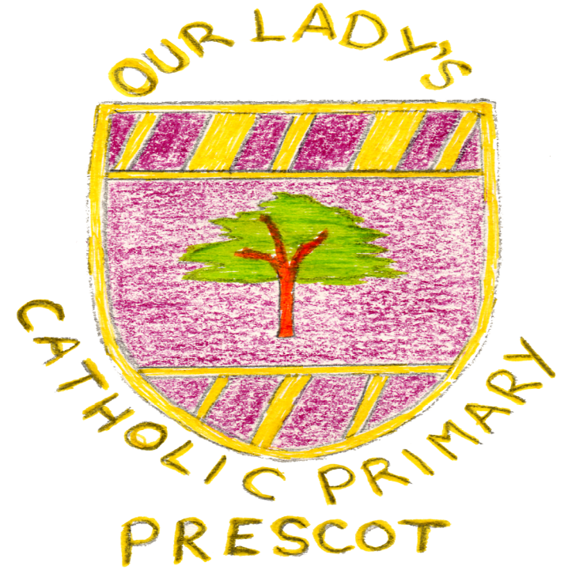

Our Lady’s Catholic Primary School

Mission Statement Document
Reviewed by our school community January 2019

Our Lady’s Catholic Primary School
Mission Statement Document

Loving

Parents/ Staff and Governors

We aim to

- foster a sense of belonging – enabling all stakeholders to have an active role in all aspects of school life.

By

- Creating a welcoming environment for all. With approachable and friendly staff who communicate well with others. We will use letters, newsletters, our website, school assemblies, Class Do Jo, collective worship and daily encounters to ensure this is maintained.

We aim to
- Respect and value ourselves and one another

By
- Ensuring our curriculum supports this through successful teaching of PSHE and SEAL. We will as a Christian community ensure that Religious Education permeates through all that we seek to achieve on a daily basis. Behaviour management techniques will be used to support children in valuing themselves and others. Our school policies will continue to support this.

We aim to
- Nurture positive relations

By
- Providing strong pastoral care for our school community. We will continue to look for ways to build on our parent partnership in order to nurture positive relations. RSE, SEAL, PSHE and a good level of communication will be used.

Children’s responses

Kind to our friends
All staff to look out for us
We are a happy school
We know how to share
Politeness
Respect for each other
Try to make sad people happy
Make new friends

Learning

Parents/ Staff and Governors

We aim to
- Provide a broad curriculum to enrich all of the children’s learning and to make accessible for all within a safe, secure environment.

By
- Tailoring it to individual needs through personalised learning. We will continue to offer one to one tuition for those who are identified as requiring it, differentiation and small group supports to be used.
- We will provide opportunities to nurture the development of the whole person including; physical, creative, social, spiritual, intellectual, and emotional.

We aim to
- Celebrate the individual achievements of all stakeholders.

By
- Whole school recognition at the weekly stars assembly, rewards within the class on a daily basis, the end of year final assembly and by celebrating differences.
Children’s Responses

- We enjoy our work
- We work hard in class
- We listen to our teachers
- We follow instruction well
- Always try our best

Reaching out to all
Parents/ staff and governors

We aim
To reach out and involve the local community including our families

By
- Continue to build and develop strong links with both parishes. We now have access to a school mini bus and we are going to utilise this in order to visit Portico parish on a more regular basis.
- Utilise the skills of local businesses to support the growth and development of our school.
- Look for ways to support parents in the education and social well being of their child by offering available courses including those for Literacy and Numeracy.
- Revise our RE Newsletter in light of a new curriculum and ensure that it is a useful tool for parents to support the spiritual development of their child.

We aim

To reach out and involve the wider community by

By

- Continuing to support worthwhile causes including, Marie Curie, Nugent Care, Willowbrook Hospice, Buckets of love project, Poppy Appeal, Children in Need and Muscular Dystrophy UK. .
- Continuing as an international school and the work this involves.
- By signposting activities that are occurring in our local community e.g. The Shakespeare Project.

Children’s responses

When we put on shows continue to invite others
CAFOD
When we pray / bidding prayers
Go to church
Care for people
Poppies
Help the Food Banks

