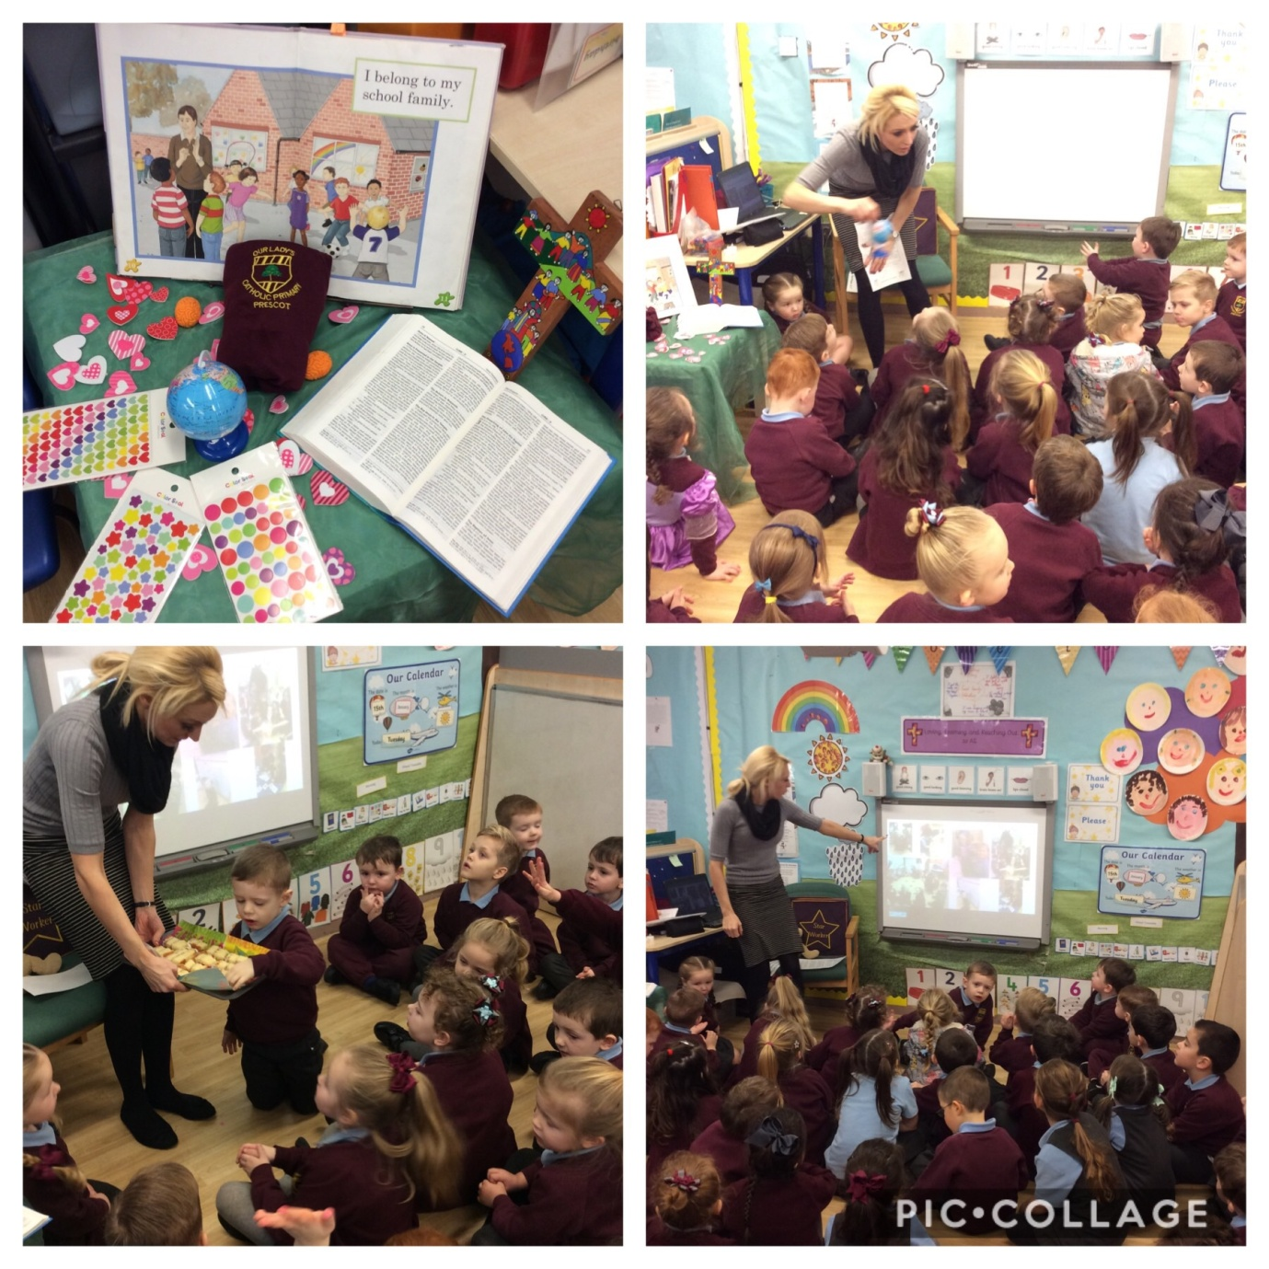
We explored our mission statement through collective worship. We talked about our mission statement using our focus table which contained foam hearts (to represent loving), brain figures (to represent learning) and a globe (to represent reaching out to all).We looked at photos of the children and staff living out our mission statement on the IWB. We celebrated going forth with milk, snacks and stickers that the children will be given when they share stories of how they are showing love, learning and reaching out to all.

