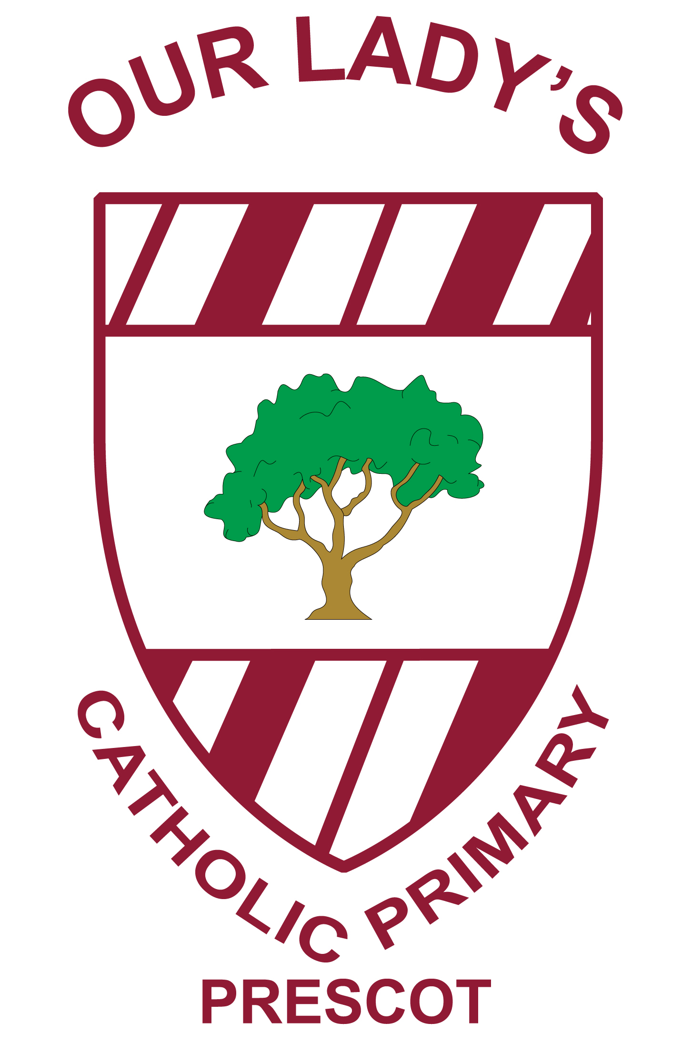
Our Lady’s Catholic Primary School

Ward Street Prescot Knowsley Merseyside L34 6JJ
Tel: 0151 477 8220 Fax: 0151 477 8221
Website:www.ourladysprescot.com
Email: ourlady@knowsley.gov.uk
Headteacher
Mr H Boyle BSc NPQH
Twitter: @ourladysprescot

“Loving Learning and Reaching out to All”
16.01.2018

Dear Parents and Carers,

Model of the Shakespeare North Theatre coming to school

As we are one of the Premier Shakespeare linked schools in Knowsley we have been offered a loan of this outstanding model for one week. The model will be on display in school from Monday January 29th. Parents and carers will be more than welcome to come in to view the model. We ask that you donate some food for the foodbank, if you can please, when you visit. The model will be on-show from 3:15 to 3:45pm. Entry to the school will be by the school office. Parents dropping off at our Breakfast Club or collecting from our After School Club may also view the model at that specific time.

Eco-Council visit to the new Prescot Fire Station
Our Eco- Council have been working with the construction company Wates since last term and have been offered a preview tour of Prescot’s new Fire Station this Thursday 18th January.

Reminder it’s Party Box School Lunch this Thursday 18th Jan. You only need £1 if you pay for dinner Y3 to Y6. It’s free to all Reception to Y2 children. No need for a packed lunch that day and you could be helping school if you choose this option.
Yours sincerely, Mr H.Boyle



SFVS

