Our Lady’s Catholic Primary School

Online Safety Newsletter: Nov 2017

Anti-bullying week: 13th - 17th Nov
Do you know the online safety lingo?

Cyberstalking is the repeated use of electronic communications to harass or frighten someone, for example by sending threatening emails or messages.

Acronyms

PIR: Parent in room

(L)MIRL: Let's meet in real life

CD9: Parents around/Code 9

ASL: Age/Sex/Location

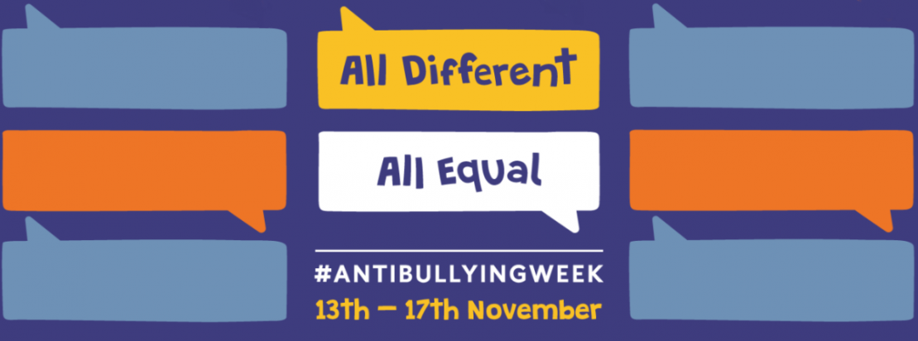

Anti-Bullying Week is coordinated by the Anti-Bullying Alliance. It shines a spotlight on bullying and encourages all children, teachers and parents to take action against bullying. The theme this year is 'All Different, All Equal.' Here are some tips from ABA if you’re worried about cyberbullying:
- Talk to your child about who they're talking to online and encourage them to think before talking to people they don't know in person.
- Try to understand and guide your child's online behaviour - negotiate and establish boundaries and discuss sensitively the issues around the concept of 'friends.'
- Familiarise yourself with the social networking sites and chat programmes your child uses. Find out more about its build-in safety functions and how they can be contacted within the service.
- Ask your child if they know how to block someone who they don't want to talk to anymore. If they don't, help them learn how to use the blocking feature.
- Use parental control software provided by your internet service provider, mobile phone network, online content provider or games console.

Sarahah – age rating 17+
Sarahah is a free social networking service for providing anonymous feedback. In Arabic, Sarahah means "frankness" or "honesty". It was originally created as a tool to provide anonymous feedback in the workplace but it’s now being used more widely. Users can either sign up through the website or by downloading an app and it can be used on its own but many users add links to their Sarahah account from Snapchat, Instagram and Facebook. Users can read and favourite messages that they receive but they can’t reply. It is causing concern among parents and child protection charities for its potential to provide a platform for cyberbullying.

The NSPCC has provided parents with these guidelines to help you keep your child safe whilst using Sarahah:
- Talk to your child regularly about what they are doing on Sarahah. Let them know they can come to you or another trusted adult if they’re feeling worried or upset by anything they have seen.
- Explore the site with your child. Understand why they like using Sarahah and make sure they know what they can do to keep themselves safe.
- Agree rules about what’s okay and what isn’t when using sites, apps and games.

